**The LED semiconductor light**

**«Armstrong-14-O» SSP-A-220-014-O-N, T-MCC,**

**«Armstrong-15-O» SSP-A-220-015-O-N, T-MCC,**

**«Armstrong-16-O» SSP-A-220-016-O-N, T-MCC**

**OPERATING MANUAL**

**TS 3461-006-41677105-10 OM**

The present operating manual (further named OM) is used for operating LED semiconductor light of “Armstrong” type (further named the light).

The OM contains construction data, operating rules and working conditions, maintenance recommendations and other data necessary for the right operating of the light.

Only after being instructed, going through safety working methods, checking of safety rules with further certifying a qualification for safety arrangements, one is admitted for electrical installation, inspection and maintenance of the light unit.

**1. Description and Operating**

**1.1 Light Assignment**

1.1.1 The light is used for inner illumination of objects.

**1.2 Technical data**

1.2.1 Supply voltage range - 140 ÷ 265 VAC (50±10%) Hz or 200 ÷ 370 VDC;

1.2.2 Humidity up to 95% (at the temperature +40°C).

1.2.3 Working temperature from minus 30°C up to plus 60°C.

1.2.4 Color temperature, K: T - (warm luminous color) 3 000 ÷ 4 000, N (normal luminous color) 4 000 ÷ 6 000.

1.2.5 Ripple factor of the light flux is not more than 5%.

1.2.6 Power factor is not less than 0,9.

1.2.7 Climatic category MCC, environmental class 1 according to IEC 60721-2-1:2013:1982, IEC 60068-1:2013

1.2.8 Electric shock protection class 1 according to IEC 60598-1.

1.2.9 The lighting source – LED semiconductor module.

1.2.10 Ingress protection rating according to IEC 529 is not worse than IP40.

1.2.11 Service life when conforming to operating conditions is not less than 100 000 hours.

1.2.12 Storage from the date of its being manufactured is 3 years.

1.2.13 Fire safety is up to IEC 60598-1, NPB 249-97.

1.2.14 Insulation resistance of live parts is not less than 20 МОm.

1.2.15 Grounding resistance is not more than 0,5 Оm.

1.2.16 The electrical and illuminating light parameters should correspond to the meanings that are pointed in the table 1.

|  |  |  |  |
| --- | --- | --- | --- |
| The light brand | The light type | Light flux*,  not less than, lm | Consumption power,  nominal**, W |
| Armstrong-14-O | SSP-A-220-014-O-N,T-MCC | 5700 | 48 |
| Armstrong-15-O | SSP-A-220-015-O-N,T-MCC | 4700 | 39 |
| Armstrong-16-O | SSP-A-220-016-O-N,T-MCC | 3600 | 30 |

* Light flux is specified for the LED module at the chip temperature of 25 C. To specify the light flux it is necessary to consider IES-file for the light.

** Consumption power value can differ by ±10%.

1.2.17 The light weight, not more than 4.5 kg.

1.2.18 Overall view, alternative constructions and overall sizes of the light are pointed on pic.1

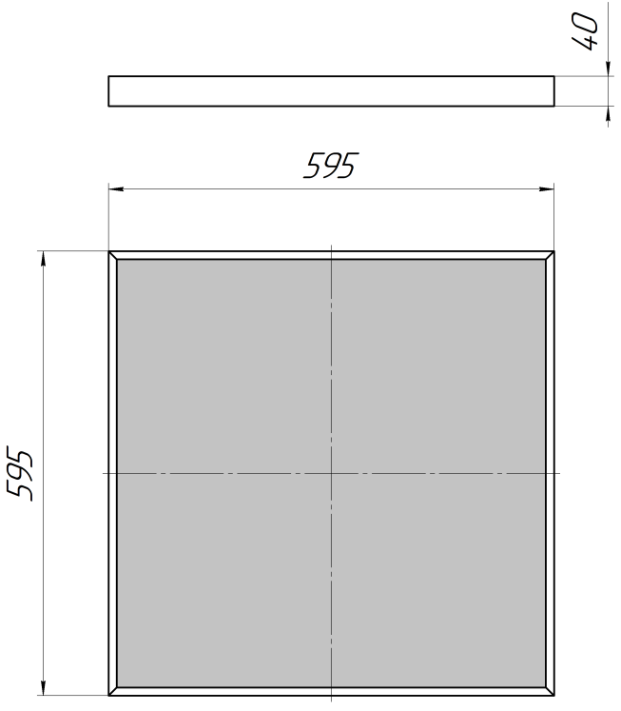

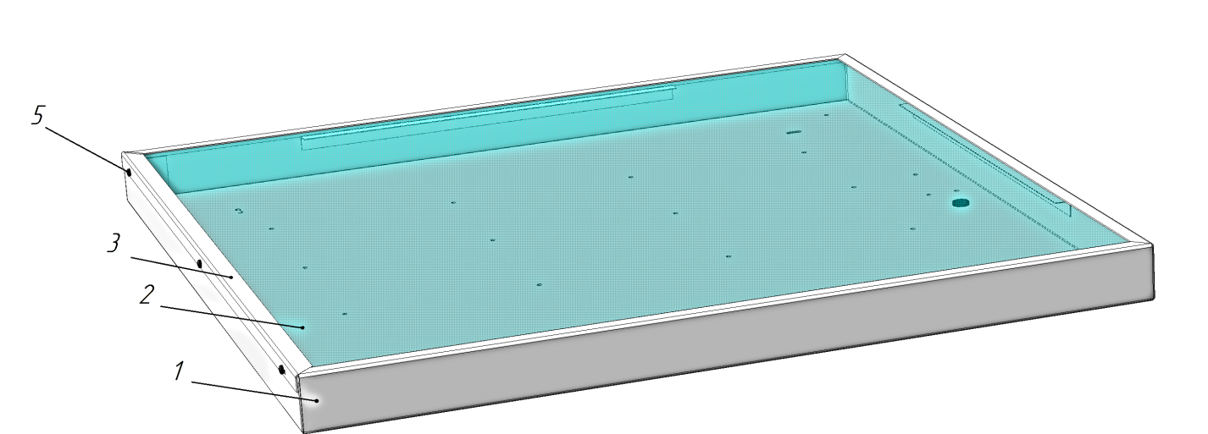 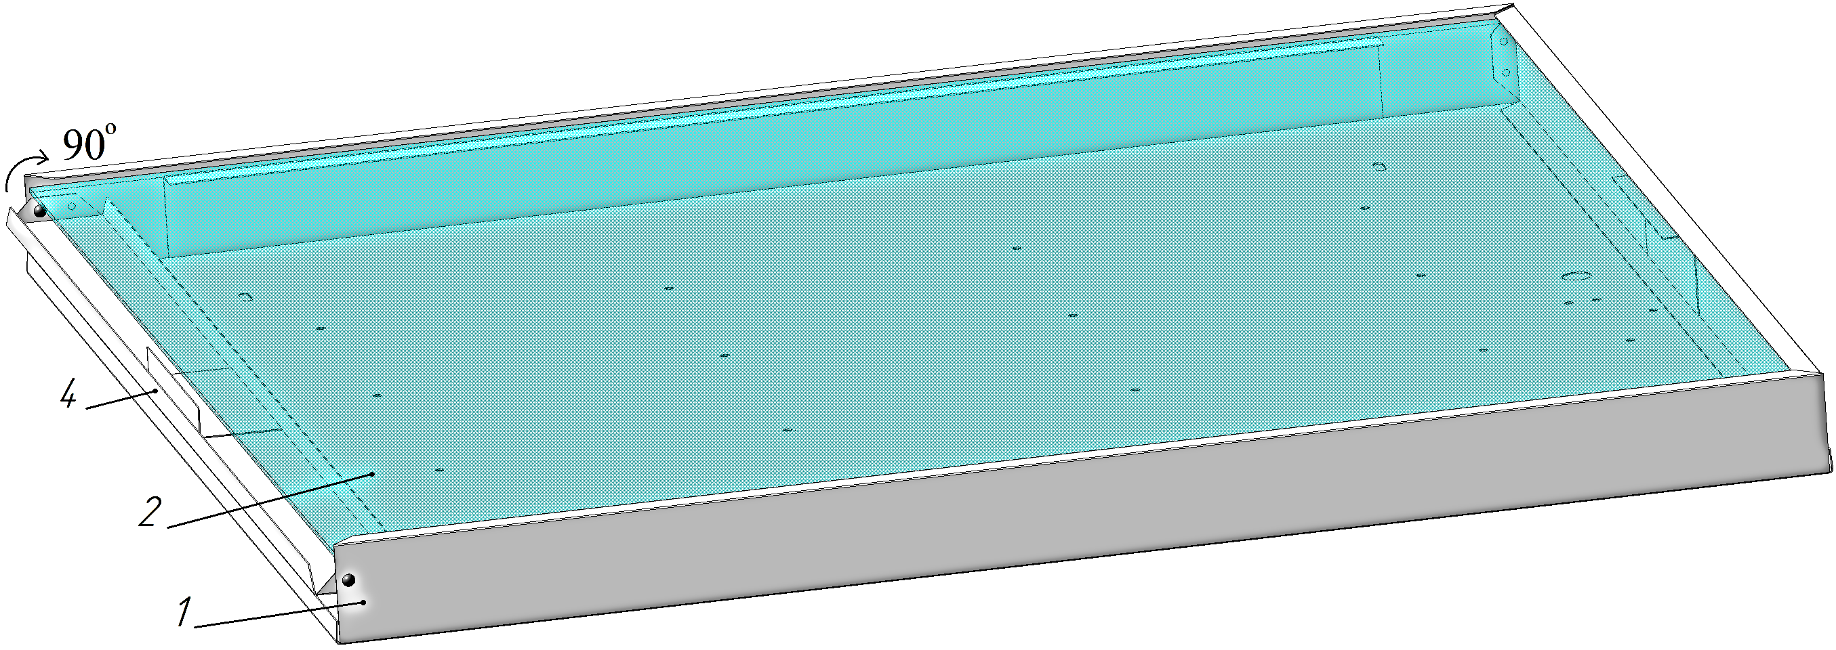

1. Pivot bar B) Clamp bar

Pic.1

**1.3 The light complectness:**

1.3.1 The set consists of:

- a light – 1 pce.,

- an operating manual – 1 pce.,

- a passport – 1 pce.,

- a package – 1 pce.

**1.4 Construction and Operation**

1.4.1 The light (see Pic. 1) consists of the housing (pos.1) which is made of the metal which is the bearing element of the light, protective opal glass (pos.2), LED semiconductor modules, driver and contact device.

1.4.2 The designation of constitutive parts of the light:

- the housing of the light (pos.1) is the bearing element on which LED semiconductor modules, driver and contact device are fixed for connection of the network wire;

- the protective opal glass (pos.2) which is made for creation of necessary light intensity curve is put into the special plots of the housing and are fixed by the corner (pos.3) by means of self-cutting screws (pos.5) or by means of pivot bar (pos.4) depending on the construction.

**Notes:** the light construction is constantly developing, that’s why changes may have place that do not affect its reliability and technical parameters.

**1.5 Marking**

1.5.1 The light marking is made according to requirements of GOST 9980.4.

1.5.2 Marking of light contains:

- the trademark of the manufacturer;

- the name of the company;

- the address of the company-manufacturer;

- the technical conditions logical number;

- the brand and type of the light;

- specified supply voltage in volts;

- max. rated input in watt;

- IP code;

- manufacturing year and month.

1.5.3 The structure of conventional value

SSP-Х-ХХХ-ХХХ-X-X-ХХХ

the letter designates a light curve group (A-cosine);

the three-number figure designates the nominal supply voltage;

the three-number figure designates a batch number; the letter designates the modification of the light construction inside the lot (O-opal diffusing glass);

the letter designates a light emission colour (N – neutral, W – warm);

the letters designate a climatic performance according to IEC 60721-2-1:2013:1982, IEC 60068-1:2013

**1.6 Packaging**

1.6.1 The package of the light is made according to GOST 12301.

1.6.2 The lights should be packed into a cargo container that provides their safety and protection against mechanical damages.

1.6.3 Manipulation signs should be marked on the cargo container: “Fragile”, “Keep dry”, “Top”, “Max quantity when stocking” according to ISO 780:2015.

**2 Intended Usage**

**2.1 Embodiment.**

2.1.1 The main embodiment of the light allows building in the ceiling space of the location.

**2.2. Preparation for Use.**

2.2.1 Installation of the light to the surface is made before connecting the light to the electrical network and the external grounding.

2.2.2 To connect the light to the power line it is necessary:

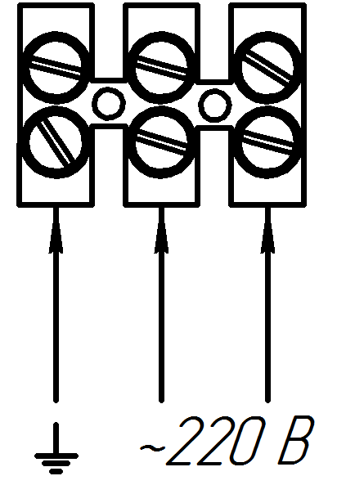- to take off the protective opal glass (pos.2), unscrew the self-tapping screws (pos.5) which are installed from the front side of the housing or unbend the pivot bar (pos.4) from the side end of the housing;

- to enter the mains wire through the hole in the light housing and connect it to the contact device as is shown on Pic. 2;

Pic.2

- to enter the external grounding wire and connect it to the connector of the contact device labeled “Заземление”;

- to install protective opal glass in reverse order in the lamp housing.

**Notes:**

The light is equipped with technological wires connected to the network contact device. When the lamp is connected to the mains, the process wires must be disconnected.

**2.3 Safety Methods.**

2.3.1 For providing safety while operating the light it is forbidden:

- to carry out any operation of the light when energizing;

- to assemble and operate the light with a damaged isolation of the wires.

2.3.2 When assembling and operating the light it’s necessary to guide:

- rules on design of power electric installations;

- the present operating manual.

2.3.3 In order to avoid electric shock the light must be grounded.

**3 Storage and transportation**

3.1 The light should be kept packed according to GOST 23216 for the storage conditions 2 (c) IEC 60721-2-1:2013:1982, IEC 60068-1:2013.

3.2. Transportation of the light can be carried out by any transport at any distance.

3.3. When keeping and transporting the light should be protected against any atmospheric fallout.

**4. Recycling data**

4.1 All the materials of which the light is manufactured are not dangerous for the life and health of people and the environment. On completing the operation of the light it should be disposed of in accordance with the present regulations.

**5. Warranty**

5.1 The manufacturer guarantees the conformance of the light to the technical specifications and normal work within 5 years since operating it at condition of observing the rules of transportation, storage and installation.

5.2 Within the warranty period damaged lights should be changed charge free by the manufacture at the conditions of the conformance to the installation and operating rules by the customer.

**6 Reclamation Data**

6.1 The manufacturer should be laid reclamation claims in case of discovering damages that may lead to the breakdown of the light before the warranty expiration.

The manufacturer’s address:

19, Leskova str., Orel, 302040, RUSSIA, JSC “Proton”.

6.2 In reclamation the light brand, damages, conditions at which they are discovered, the whole operation period should be specified.

There should be attached a copy of the payment document for the light.

**7 Acceptance Certificate**

7.1 The light is manufactured and approved in accordance with the present technical specifications TS 3461–006–41677105–10 and approved to be suitable for the operation.

Placeholders QCD stamp

________________________________

Date